Winter Class Details
January-April 2020
Due Tuesday, September 17, 5pm – Late Class Details WILL NOT BE ACCEPTED.
All Information must be typed. Handwritten will not be accepted.
Instructor Information
Name:
Address:
City: |  | State: |  | Zip:
Email: |  | Phone:
Can we give the following to the public? ☐Phone ☐Email
Additional Instructors: | ☐Yes - Name: | Phone:
 | ☐No | Email:
Signature: |  |  | Date:

Class Information
Class Title:
Ages: |  |  | Maximum # of Students: |  |  |  | Supply Fee:
Course Description:
Descriptions must be brief. Activity Guide space will be limited to 40 words or less and may be modified at the discretion of the supervisor. In your description, include any material/supply fee that will be charged to the participants. Include any specific attire or supplies that participants must bring to class. Reminder: You may be asked to present a receipt for materials used for class when charging a supply fee. PVRPD reserves the right to modify information.
Activity Guide Description:

Online Description:

NO CLASS DATES:
Class #  (Office Use Only) |  |  | Time: | Days: |  | Dates: |  | Cost: | Location:  (Office Use Only)
Class #  (Office Use Only) |  |  | Time: | Days: |  | Dates: |  | Cost: | Location:  (Office Use Only)
Class #  (Office Use Only) |  |  | Time: | Days: |  | Dates: |  | Cost: | Location:  (Office Use Only)
Class #  (Office Use Only) |  |  | Time: | Days: |  | Dates: |  | Cost: | Location:  (Office Use Only)
Room Set up & Notes:
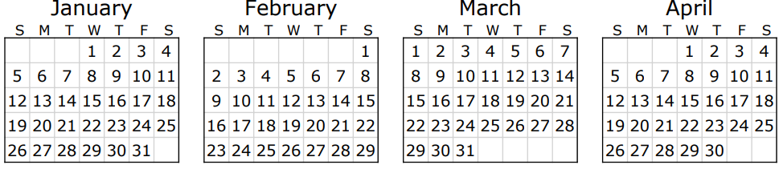

00

- Wednesdays - Community Center available before 4pm
- Sundays - Community Center available after 4pm

- No contract classes at Comm. Center until after 3pm
- District Office/Facilities Closed
Holiday breaks for PVSD

